# *Contact Center Production Planning Out-of-the-Box Presentation Objects*

# Overview

## Context

Production planning is an important aspect of contact center operations management; it involves tracking forecasted arrivals against actual arrivals, optimizing staffing needs, and managing service levels. Here are some common questions projects need to address on regular basis:

* How many contacts have we received, what does the call pattern look like at hourly, daily and weekly level?
* How frequently has the forecast been adjusted? How does the original forecast compare to the actual contacts received?
* Is there a meaningful variance against the forecast; and if so, is the variance observed for a specific queue or common to all queues?
* Is the contact center properly staffed? Based on volume and staff availability, which day is “critical day” and needs to be monitored and managed closely?
* How do calls “flow through” IVR menu? How many calls are contained at each IVR path?
* Are we managing to our targets? How big is our risk based on the performance in the past few days?
* We had a few “bad days”, can we still meet our KPRs for this planning horizon? What would be the minimum performance target we must achieve for the next few days?
* Why is the service level lower than expected for a particular day?

Visibility to near real time performance is critical to keep all levels of staff informed to ensure alignment with the pre-established targets. The Contact Center Production Planning module covers three distinct sub modules or core functionalities:

1. Actual Arrivals Monitoring and Service Level Conformance,
2. Arrivals Monitoring (both Actual and Forecasts) and Service Level Conformance, and
3. Staff Planning.

Each of these sub modules can be implemented independently to suit specific project needs. For example, the first sub module, *Arrival Monitoring and Service Level Conformance* tracks contact actuals and performance at 30 minute intervals, which may be rolled up to an hourly, daily and weekly level; the second sub module, *Arrivals* *Monitoring (includes both Actuals and Forecasts) and Service Level Conformance*, provides forecasted volumes and performance metrics that management can use as guidance for day-to-day planning. The three sub modules, when implemented together, will provide a complete picture on the actual performance as compared with the forecasts in a specified production plan.

## Business Purpose

The Contact Center Production Planning module receives contact data by interval from the Automatic Call Distributor (ACD) and Interactive Voice Response (IVR). It also receives data from the Work Force Management (WFM) application. This module can read data from a properly formatted external source, e.g., ARENA staffing optimization models, which provides pre-established targets on key production planning metrics.

The tools that Contact Center Production Planning module offers allow management to be informed on performance, spot trends, stay on top of issues, anticipate and address risks, and take actions at the earliest possible stage to minimize cost and ensure service delivery.

## Benefits

The Contact Center Production Planning module enables the client and MAXIMUS management to monitor performance, anticipate call demand, establish realistic ongoing service targets based on past performance, and provide insight into areas for continuous process improvement. The Contact Center Production Planning module provides project management with a number of benefits:

* Enables timely and cost effective communication on call volumes, performance, handle times, and staffing levels with client and among the interval parties.
* Provides near real time performance monitoring, keeps client and MAXIMUS management informed on performance, and helps plan actionable ad-hoc events (outbound campaign) with confidence.
* Provides near real time visibility with the ability to make better decisions faster: gains time for management to react quickly to unexpected events, such as call volume surges, system issues, and unplanned staff leave, by re-arranging resources and planning over time if necessary.
* Focuses on self-service accessibility to monitor how many customers begin self-service via IVR including containment rates compared to overall call volume.
* Automates subscriptions and alerts for information when needed or at scheduled intervals.
* Supports quick ad-hoc analysis and anomaly diagnosis around contact arrival, IVR, and service performance by providing dashboards and reports at meaningful dimension and granularity.
* Enables quick root cause analysis by drilling outcomes and metrics into necessary detail level through traceable reporting.
* Automatically stores historical forecasts and enables assessment of the quality of the initial forecast and how frequently the forecast was adjusted. Forecast accuracy can be illustrated.

# Contact Center Production Planning Out-of-the-Box Presentation Objects

Contact Center includes a series of “out of the box” dashboards, reports and analytics. These serve as the basis for many mandatory state reports and best practice data visualizations, based on years of experience in administering Medicaid enrollment and CHIP programs and are already in place at various MAXIMUS sites.

By default the notion of interval in this module is set at 30 minutes. Below we list the dashboards and reports provided by each sub module:

a) Arrival Monitoring and Service Level Conformance

Table 2.1: Presentation Objects for Arrival Monitoring and Service Level Conformance

| Name | Business Purpose | Description | Consumer |
| --- | --- | --- | --- |
| **Dashboards** |  |  |  |
| Contact Center Actual Arrivals and Performance Dashboard | This dashboard is a key management tool as it provides visibility into contact actual arrival volumes and near real time service performance to ensure the contact center is behaving as expected.  When deployed together with second sub module, actuals and forecasts will be deployed in one dashboard: the Arrivals and Performance Overview Dashboard. It triggers alerts and helps Contact Center Management react quickly to unexpected surges in volumes, meaningful deviations from the expected forecast or unplanned staff leave. | ***Data Metrics:***  1) Contact Arrivals (Tab 1)   * Actual contacts created * Actual contacts offered * Actual contacts handled * *Actual contacts transferred*   Displayed as line charts (x-axis is each day of the month) in separate charts.  2) Service Performance(Tab 2)   * Actual Average speed to answer (ASA) * Abandonment rate (AB Rate) * Actual average handle time (AHT) * Actual service level (% answered within SLA) * *Actual % calls result in a transfer*   Displayed in a table matrix with the value of the metric for the interval chosen and the graph with 6-day rolling trend.  For metrics such as actual ASA and AHT, control charts will be displayed to include thresholds with green, yellow and red where outliers can be easily identified.  For those metrics with two tiers (ASA- 80% in X seconds, and 100% in Y seconds), user can select tier from a dropdown adjacent to the table/control chart. For instance, tier 1 is 80% of calls in 120 seconds. Please see mockups.  ***Filters:***   * Select desired date range, including past months. Default is month-to-date. * Select the filter items from drop-downs for contact type (inbound call, web chat, etc), queues, or program. Aggregate date is available in all drop-downs by selecting “All”.   ***Capabilities, Alerts and Modifications:***  Users can analyze trends for the specified time period.  Users can set up alerts and email notifications to “push” actionable information to users when thresholds exceed or are below set boundaries (min/max) for incoming contact volumes. This is most beneficial when used in conjunction with production planning forecasts when meaningful deviations between actual and forecasts are escalated to management.  In addition, real-time monitoring of the AHT by queue can help detect outliers and alert management before other metrics such as ASA get affected. Contact Center management can realign resources with the appropriate capabilities as needed. | Project Manager, Contact Center Manager, Reporting Analyst, Work Force Management Analyst |
| Contact Center Actual Arrivals and Performance Intraday Dashboard | This dashboard tracks intraday metrics for contact actual arrivals and service performance to assess if any immediate actions need to meet the goal of the current or next day. | This is parallel with Actual Arrivals and Performance Dashboard except that the x-axis is interval instead of day. Same filters are applicable here.  Users can select the day they want to see (default is current day). | Contact Center Manager, Supervisors, Reporting Analyst, Work Force Management Analyst |
| Contact Center  IVR Usage Dashboard | This dashboard provides high level IVR information, such as containment and drills into task data related to IVR paths to help highlight problem areas and opportunities for improvement for management. | ***Data Metrics:***   1. Global View (Tab1)  * Contacts created * Contacts offered to ACD * Contacts contained in IVR * IVR containment rate * % contacts contained at each of the top five IVR paths * Average time spent in IVR   Metrics above are all actuals. IVR containment rate is displayed in histogram; the rest are displayed in line chart by contact type.   1. Self Service Path View (Tab 2)   For each self service path :   * Contacts entering * Contacts transferred * Contacts completed * Minutes in IVR transferred * Minutes in IVR completed   Metrics above are all actuals. Displayed as line charts.  ***Filters:***   * Select date range desired, including past months up to 12 months. Default is month-to-date.   ***Capabilities, Alerts and Modifications:***  Users can analyze trends for the specified time period. | Contact Center Manager, Reporting Analyst, Work Force Management Analyst |
| **Reports** |  |  |  |
| Contact Center Actual Arrivals and Performance Monthly Report | This report serves as service level deliverable for each month. Managers may also use this report internally for middle-of-month performance review. Historical data will be used for determining call trend and analyze handle time, etc. | ***Data Metrics:***  For each contact type (i.e., inbound calls and web chat):   * Contacts created * Contacts offered * Contacts contained * Contacts abandoned * Contacts handled * *Contacts Transferred* * % answered in service level AHT * AB rate * ASA * AHT * *% calls result in a transfer* * Available headcount * Max Speed to Answer   Metrics above are all actuals.  Displayed as grid. Each row of the report represents a day, with the option of displaying weekly and monthly subtotals.  ***Filters:***   * Select desired date range, including past months. Default is month-to-date. * Select the filter items from drop-downs for contact type (inbound call, web chat, etc), queue, or program. Aggregate date is available in all drop-downs by selecting “All”. | Contact Center Manager, Reporting Analyst, Work Force Management Analyst |
| Contact Center Actual Arrivals and Performance Intraday Report | This report supports management to assess the need for staff adjustments and/or overtime planning.  Historical interval data are used to assess the intra-day call pattern.  In addition, the WFM Analyst may use past interval performance to make improvements on staff schedules. | This is parallel with Actual Arrivals and Performance Monthly Report except that the rows represent intervals.  Users can select the day they want to see (default is current day). | Contact Center Manager, Reportng Analyst, Work Force Management Analyst |

b) Arrivals Monitoring (both Actual and Forecasts) and Service Level Conformance

Table 2.2: Presentation Objects for Arrivals Monitoring and Service Level Conformance

| Name | Business Purpose | Description | | Consumer |
| --- | --- | --- | --- | --- |
| **Dashboards** |  |  | |  |
| Contact Center Arrivals and Performance Overview Dashboard  *This includes actual, forecasts, and forecast-to- actuals deviations.* | This dashboard delivers the "pulse" of the contact center operation: current demand in relation to predicted demand, and prominent performance measures together with alerts/early warnings support business leader assessments of operational visibility.  Like the **Actual** Arrivals and Performance Dashboard, it provides visibility into contact arrival volumes and near real time service performance to ensure the contact center is behaving as expected.  In addition to information in the Arrivals Dashboard, this complete version offers forecast vs actual variance and detects issues or early signals on assumption changes (e.g. call pattern switch, AHT).  This dashboard will **replace** the Actual Arrivals and Performance Dashboard when this sub module is deployed for the project.  Alerts are automatically triggered and help Contact Center Management react quickly to unexpected surges in volumes, meaningful deviations from the expected forecast or unplanned staff leave. | ***Data Metrics:***  1) Contact Arrivals (Tab 1)   * Actual and forecast contacts created * Actual and forecast contacts offered * Actual and forecast contacts handled * *Actual and forecast contacts transferred*   Displayed as line charts (x-axis is each day of the month) by contact. Actuals and forecasts must overlay in the same chart.  In a table matrix, display, for each of the above metrics, actual, forecast, and percentage error.  2) Service Performance(Tab 2)   * Actual and forecast average speed to answer (ASA) * Actual and forecast % Answered / Abandonment rate (AB Rate) * Actual and target average handle time (AHT) * Actual and forecast service level (% answered within SLA) * *Actual and forecast % calls result in a transfer*   Displayed in a table matrix for each metric in the list above with the value of the metric (actual, forecasts, percentage error) for the interval chosen and the graph with 6-day rolling trend.  For metrics such as actual ASA and AHT, control charts will be displayed to include thresholds with green, yellow and red where outliers can be easily identified.  For those metrics with two tiers (ASA- 80% in X seconds, and 100% in Y seconds), user can select tier from a dropdown adjacent to the table/control chart.  ***Filters:***   * Select desired date range, including past months. Default is month-to-date. * Select the filter items from drop-downs for contact type (inbound call, web chat, etc), queue, or program. Aggregate date is available in all drop-downs by selecting “All”.   ***Capabilities, Alerts and Modifications:***  Users can analyze trends for the specified time period.  Users can set up alerts and email notifications to “push” actionable information to users when thresholds exceed or are below set boundaries for incoming contact volumes. Meaningful deviations between actual and forecasts are escalated to management. Users have the flexibility to define tolerance thresholds.  In addition, real-time monitoring of the AHT by queue can help detect outliers and alert management before other metrics such as ASA get affected. Contact Center management can realign resources with the appropriate capabilities as needed.  If any of the following metrics deviates from their forecasts beyond threshold values, users can set up alerts to be emailed to contact center managers and production planners: Contact Created, Contact Offered, AB rate, ASA, Service Level, AHT. The Contact Center Arrivals and Performance Overview Dashboard can be used for researching additional details. | | Contact Center Manager, Reporting Analyst, Work Force Management Analyst |
| Contact Center Arrivals and Performance Overview - Intraday Dashboard  (This includes Forecast-to- Actuals Deviations) | This dashboard tracks intraday metrics for contact arrivals and service performance to assess if any immediate actions need to meet the goal of the current or next day. | | This is parallel with Arrivals and Performance Overview Dashboard except that the x-axis is interval instead of day. Same filters are applicable here.  Users can select the day they want to see (default is current day). | Contact Center Manager, Reporting Analyst, Work Force Management Analyst |
| Contact Center Forecast Accuracy Dashboard | This dashboard allows users to assess the quality of historical forecasts in predicting actuals, and to track the frequency for making forecast adjustments. This targets the effectiveness of making forecast adjustments. | ***Data Metrics:***   * Number of forecasts in each planning horizon * Initial forecast vs actual variance (forecast to actual deviation) * Final forecast vs actual volume variance * Relevant notes for updates to forecast: It is mandatory for users to enter notes when updating a forecast. All notes for the specific date range will be displayed here. * Service level * Overall status (as Excellent, Good, and Poor) categorizing each month based on forecast quality and performance   + Excellent: forecast was adjusted less than a threshold and SLR was met.   + Good: forecast was adjusted more frequently than a threshold and SLR was met   + Poor: SLR was not met.   Historical forecasts are displayed in a table matrix with the row representing a month.  ***Filters:***   * Select date range desired, including past months. Default is year to date. * Select up to three forecast versions to compare forecast volumes and headcounts. These will be presented in a line graph.   ***Capabilities, Alerts and Modifications:***  Users can analyze trends for the specified time period.  Alerts can be set up to inform management of the frequency of adjustments to forecasts. Basically, this serves as a warning against over adjustment.  In addition, management has visibility in event planning integration- which could drive the forecast adjustment. | | Contact Center Manager, Production Planner |
| **Reports** |  |  | |  |
| Contact Center Arrivals and Performance Monthly Report  (This includes Forecast-to- Actuals Deviations) | This report serves as service level deliverable for each month. Managers may also use this report internally for middle-of-month performance review. Historical data will be used for determining call trend and analyze handle time, etc  In addition to information in the Actual Arrivals Report, this complete version offers forecast vs actual variance and detects issues or early signals on assumption changes (e.g. call pattern switch, AHT). | | ***Data Metrics:***  For each contact type (i.e., inbound calls and web chat):   * Contacts created * Contacts contained * Contacts offered * Contacts abandoned * Contacts handled * *Contacts Transferred* * % answered in service level AHT * AB rate * ASA * AHT * *% calls result in a transfer* * Max Speed to Answer   Displayed as grid. Each row of the report represents a day, with the option of displaying weekly and monthly subtotals.  For each metrics, report actuals, forecast, and variance (value and percentage).  ***Filters:***   * Select desired date range, including past months. Default is month-to-date. * Select the filter items from drop-downs for contact type (inbound call, web chat, etc), queue, or program. Aggregate date is available in all drop-downs by selecting “All”. | Contact Center Manager, Production Planner, Reporting Analyst |
| Contact Center Arrivals and Performance Intraday Report  (This includes Forecast-to- Actuals Deviations) | This report can be leveraged on critical days to assess the need for staff adjustments and/or overtime planning.  In addition to the information in the Actual Arrivals Report, this complete report allows users to see how the production plan is executed on daily basis and to assess if pattern/target deviation needs to be addressed. | | This is parallel with Arrivals and Performance Monthly Report except that the rows represent intervals.  Users can select the day they want to see (default is current day). | Contact Center Manager, Production Planner, Reporting Analyst |

c) Staff Planning

Table 2.3: Presentation Objects for Staff Planning

|  |  |  |  |
| --- | --- | --- | --- |
| Name | Business Purpose | Description | Consumer |
| **Dashboards** |  |  |  |
| Contact Center Staffing Analysis Dashboard | This dashboard shows whether contact center is adequately staffed at daily or 30 minute interval level.  It provides insights on the following questions:   * What hour / which day is the most critical “managing point” and may significantly impact performance? * Why the total available labor minutes seem adequate, however, contact center is still struggling to meet the KPR?   Contact Center management and analysts can assess the performance of the workforce scheduler via the difference between scheduled and requested headcounts. In addition, users can look into the variance between actual and scheduled headcounts.  To better understand this variance, absenteeism is available in the Agent Performance Module. | ***Data Metrics:***  1) Staffing at Daily Level (Tab 1)  For each agent type  Headcount   * Forecast headcount available * Actual headcount available   Labor Minutes   * Forecast labor available minutes * Scheduled shift minutes (*\* in agent performance module)* * Actual labor minutes available   For all above metrics, overlay actual and forecast in one chart with actuals represented in histogram and forecast in line chart (x-axis is day of the month/interval of the day).  In a table matrix, present the follow staffing and performance metrics:  Headcounts variance   * Actual headcount available - forecast headcount available * Actual ASA * Service Level ASA * Actual AB Rate   Labor minutes variance   * Actual labor minutes available- scheduled shift minutes * Scheduled shift minutes – forecast labor minutes * Actual ASA * Service Level ASA * Actual AB Rate   2) Staffing for Intraday intervals (Tab 2)  This is parallel to Tab 1.  ***Filters:***   * Select agent type and date range where the staff will be analyzed. * For Tab 1, default is month-to-date. For Tab 2, default is current day.   ***Capabilities, Alerts and Modifications:*** Users can set up alerts to be generated for daily and hourly metrics to highlight in red those days / intervals where staff shortfall exceeds user defined threshold level. | Contact Center Manager, Production Planner |
| Contact Center Staff Planning and Execution Assessment Dashboard | This dashboard summarizes staffing performance over a longer horizon, e.g., six months or two years, and provides insights on a) how is call center managing on normal days when SLR should be met, b) how is call center managing during challenging conditions (high volumes, or staff shortfall), and c) how is call center managing during relatively slow periods (lower than forecasted volumes, or actual staff higher than forecasted). | ***Data Metrics:***   |  | | --- | | Staff Plan Assessment at Monthly Level • Number of months where SLR was met (or not met) • Number of days where SLR was met (or not met) • Number of days where staff and forecast variance are both within tolerance threshold and SLR was met (or not met) The above three metrics are presented in pie chart.  • Number of days where staff variance (actual – forecast) is within threshold • Number of days where staff shortfall (forecast - actual) exceeds threshold • Number of days where staff excess (actual – forecast) exceeds threshold The above metrics are presented in horizontal bar chart.  • Number of days where forecast is within tolerance threshold, staff excess is more than threshold, and SLR was met (or not met) • Number of days where forecast is within tolerance threshold, staff shortfall is more than threshold, and SLR was met (or not met) • Number of days where forecast is below tolerance threshold, staff is within threshold, and SLR was met (or not met) • Number of days where forecast is above tolerance threshold, staff is within threshold, and SLR was met (or not met)  The above four metrics are displayed as doughnut chart. Thresholds are set for each metric; highlight in red those days where the value exceeds the threshold.  ***Filters***:   * Select desired date range, including past months. Default is current quarter. * Select the filter items from drop-downs for contact type (inbound call, web chat, etc) and metric (in this case: contact created, offered, handled). Aggregate date is available in all drop-downs by selecting “All”.   ***Capabilities, Alerts and Modifications:***  Users will define conditions (threshold around above data metrics) based on which staff plan execution will be assessed. The dashboard will generate alerts for daily and hourly metrics and highlight in red the months where staff plan execution is poor, good, and excellent. | | Contact Center Manager, Production Planner |
| ***Reports*** |  |  |  |
| Staffing Analysis Monthly Report | This report allows management to check if the forecast / required staff level has been achieved consistently. | ***Data Metrics:***  Headcount   * Forecast headcount available * Actual headcount available   Labor Minutes   * Forecast labor minutes available * Scheduled shift minutes * Actual labor minutes available * Actual labor minutes - scheduled shift minutes * Scheduled shift minutes – forecast labor minutes * Service level * ASA * AB Rate   Displayed as a grid. Each row of the report represents a day. Grid will display weekly and monthly subtotals.  ***Filters:***   * Select agent type and date range where the staff will be analyzed. Default is current month. | Contact Center Manager, Production Planner |
| Staffing Analysis Intraday Report | This report provides data on how forecast / required staff level has been met at interval level.  The production planner and WFM analyst will run this report periodically to assess whether these are certain periods throughout the day when the call center has been consistently understaffed or overstaffed. | This is parallel with Staffing Analysis Monthly Report except that the rows represent intervals.  Users can select the day they want to see (default is current day). | Contact Center Manager, Production Planner |

# 

# Operational Dashboard Detail

## Contact Arrivals and Performance Overview Dashboard

### Contact Arrivals Tab

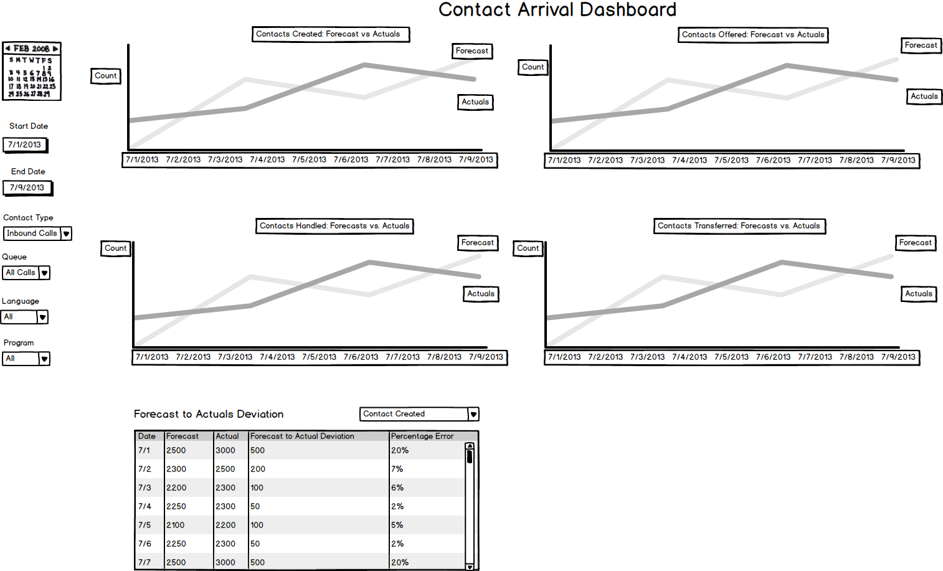

### Service Performance Tab

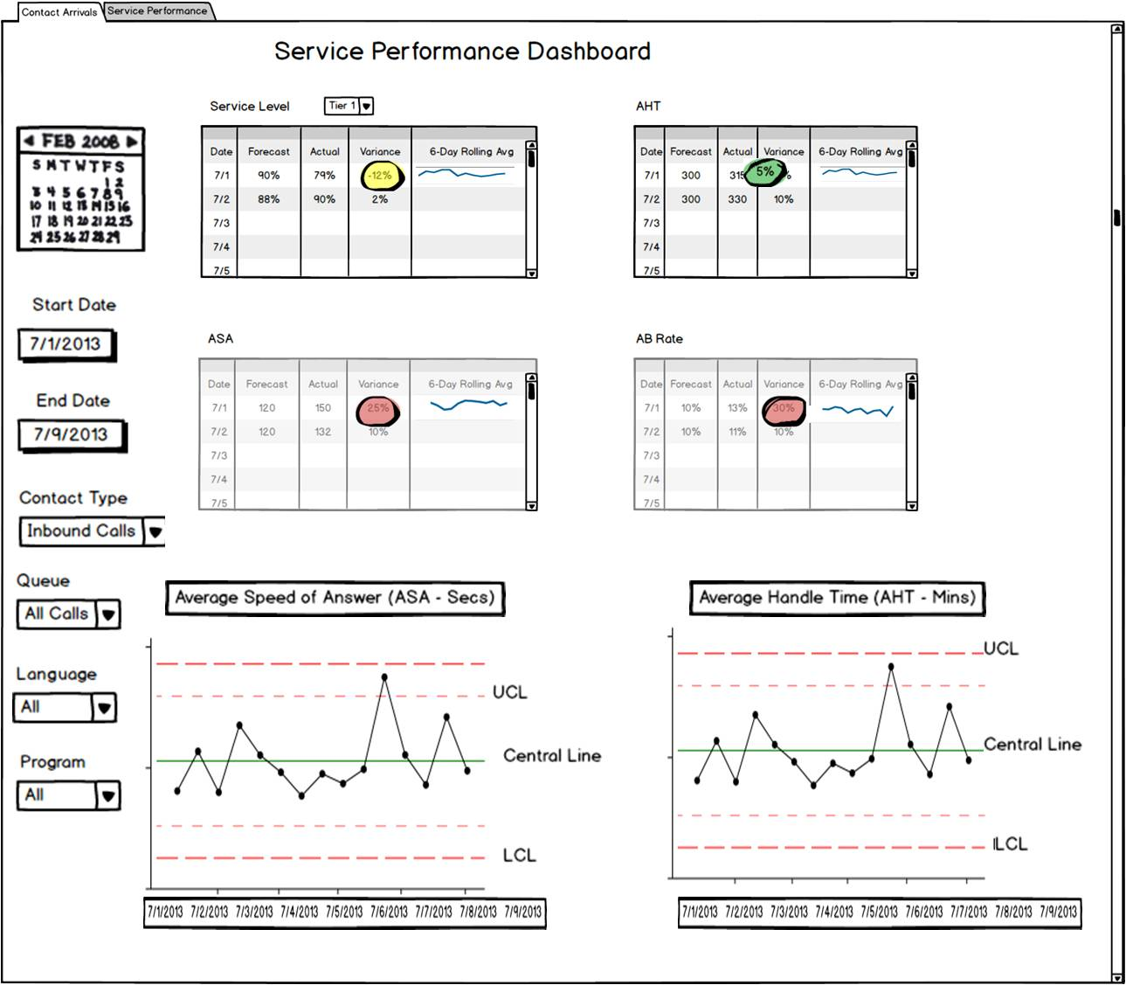

## Contact Center Staffing Analysis Dashboard

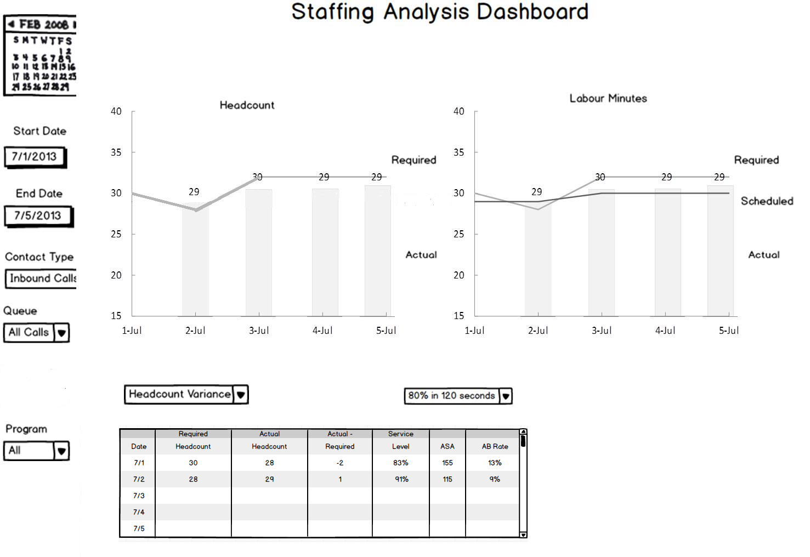

## Contact Center Forecast Accuracy Dashboard

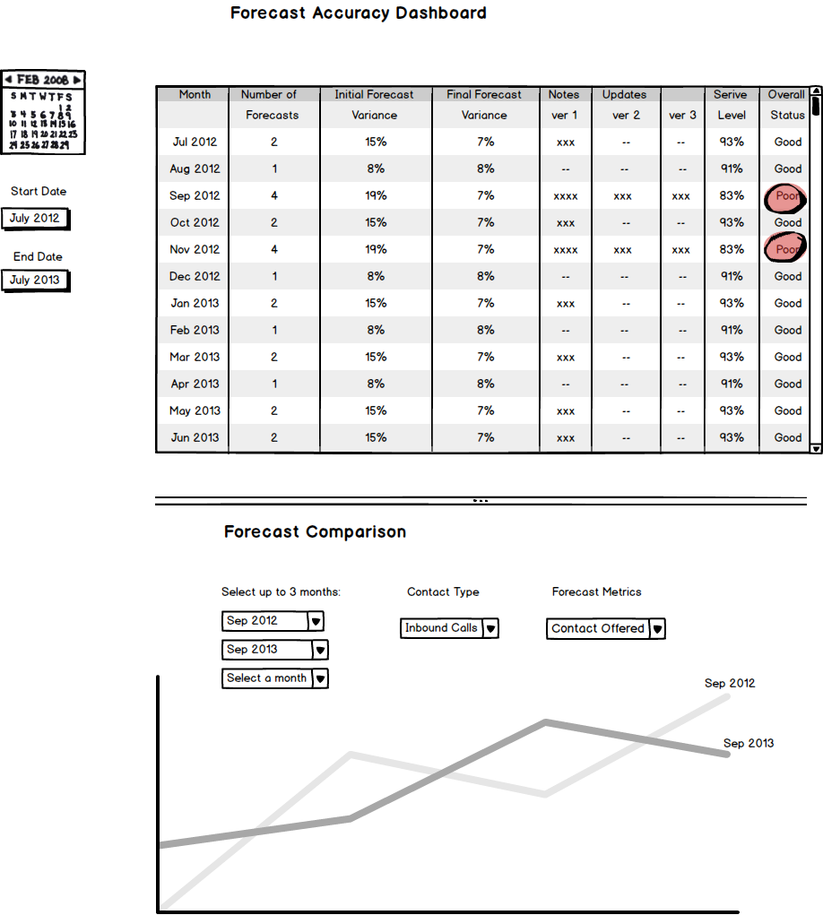

## Contact Center Staffing Analysis Dashboard

